Angular Assignment:

1. GitHub link: <https://github.com/rhythm-roshan/nagp-angular>
2. Link : <http://calm-sister.surge.sh/dashboard/state>

Note: login: user: rhythm & password: rhythm or user: admin & password: admin

1. Working of the application:
2. Without Login – Main screen is dashboard screen which consists of covid-19 data state wise

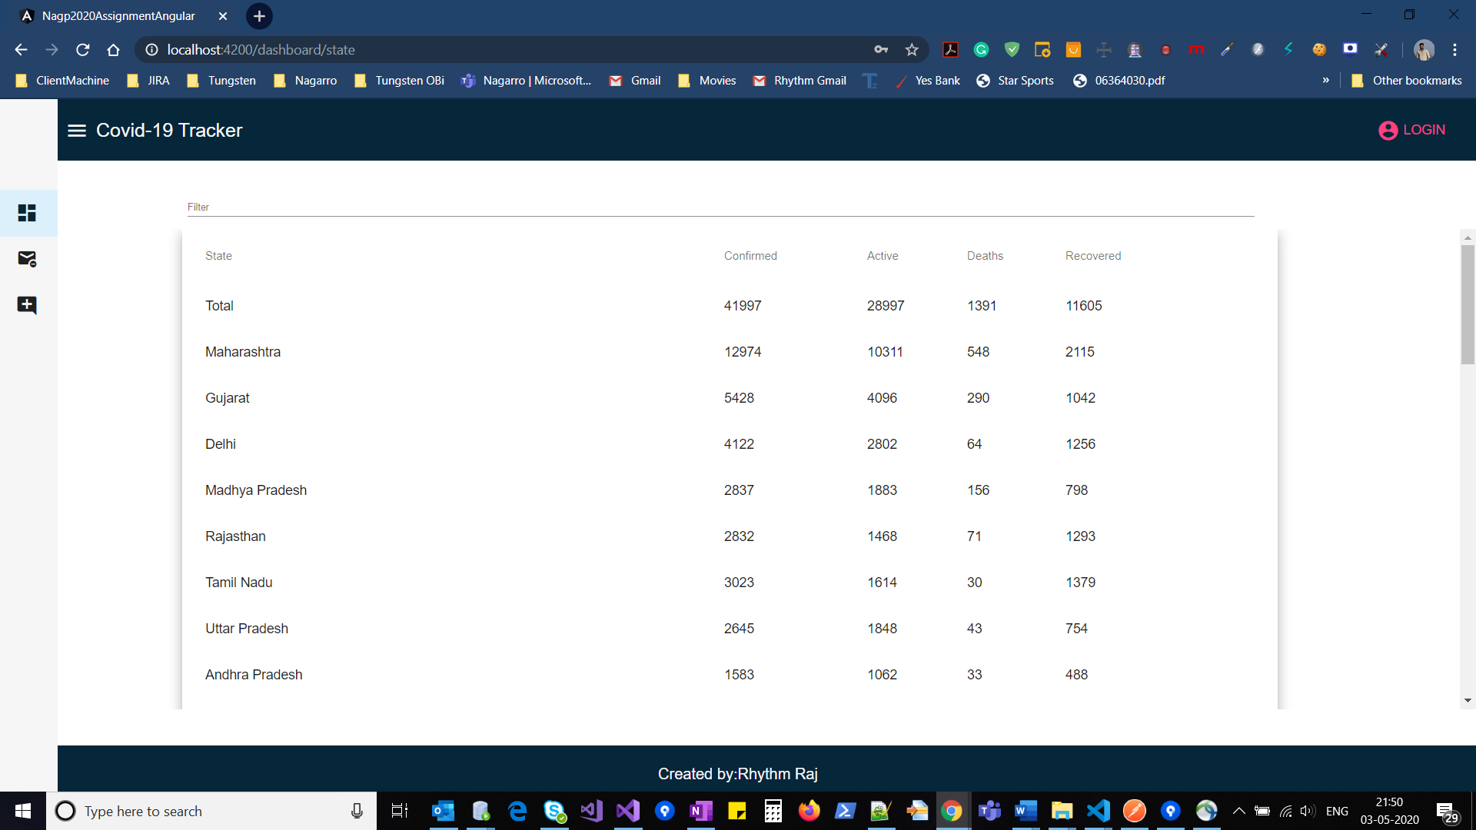

1. Upon clicking each state, it will show the list of districts in that state

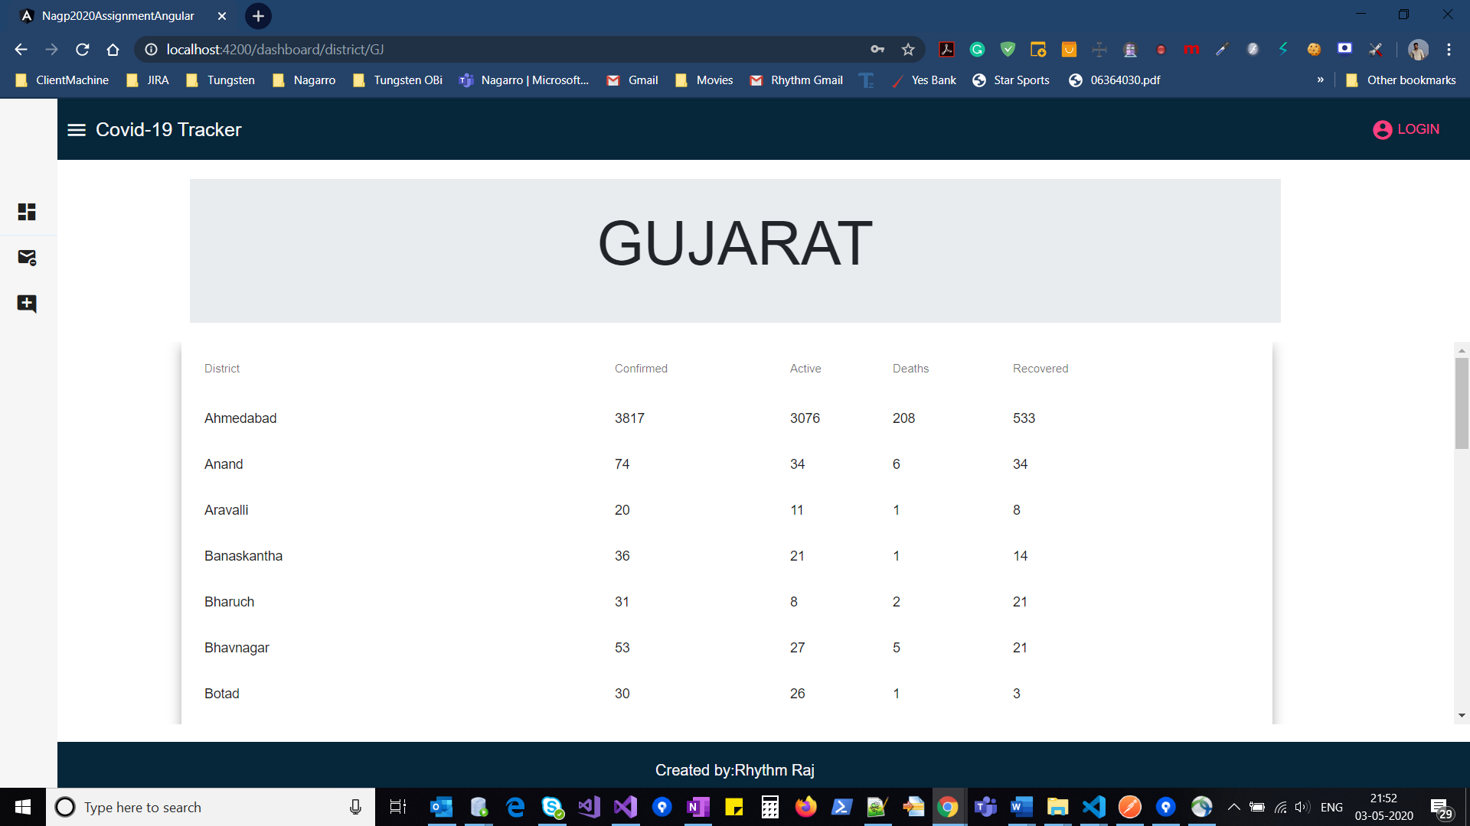

1. Side Nav bar: Toggle Nav bar to route between the pages

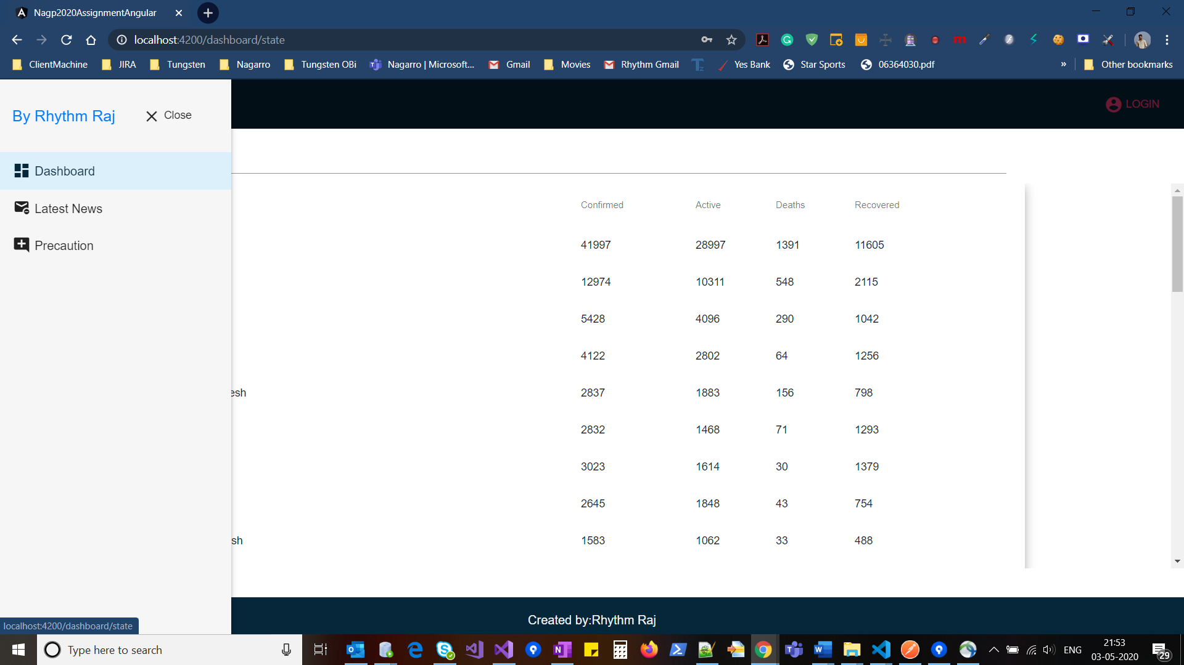

1. Latest News which will be posted by admin:

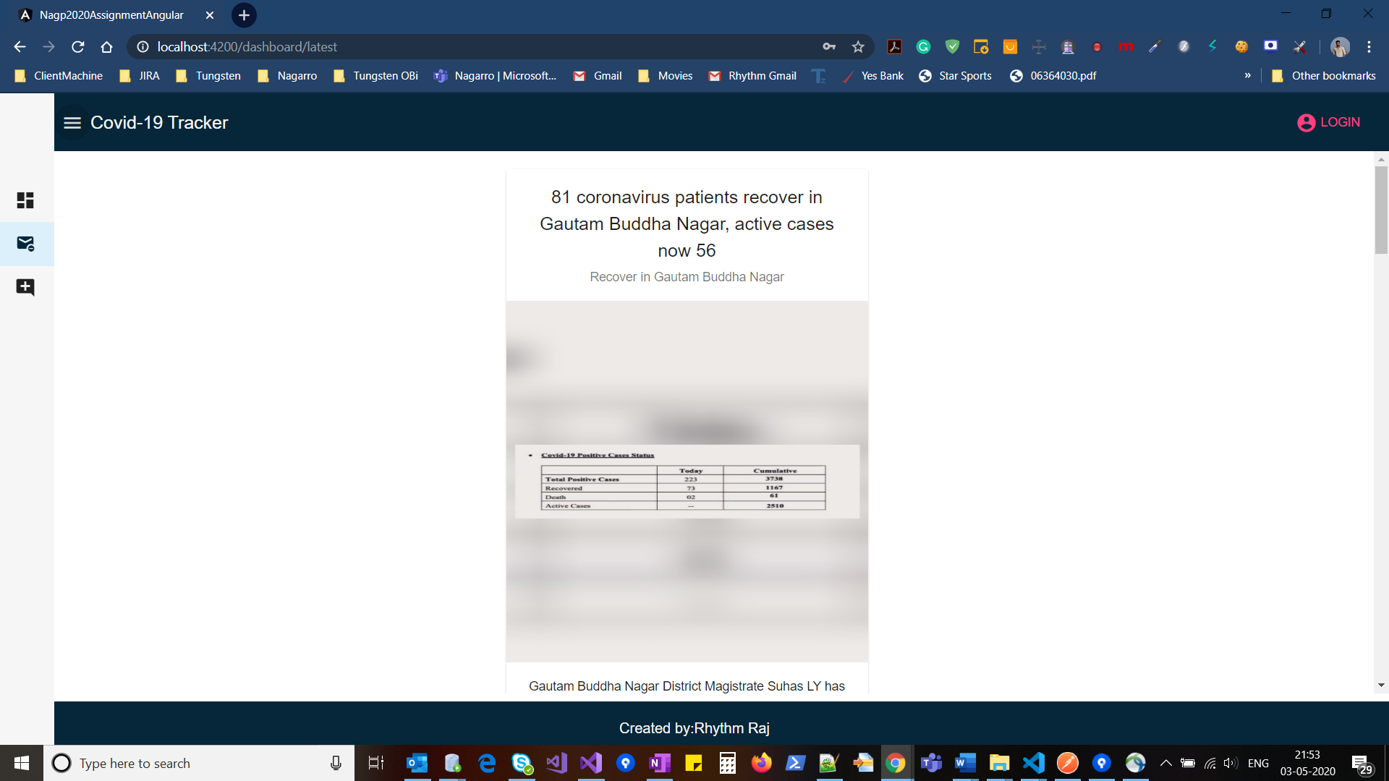

The latest news has title, description, image, summary and read more functionality.

1. Precaution: This screen consists of few measures which is published by WHO.

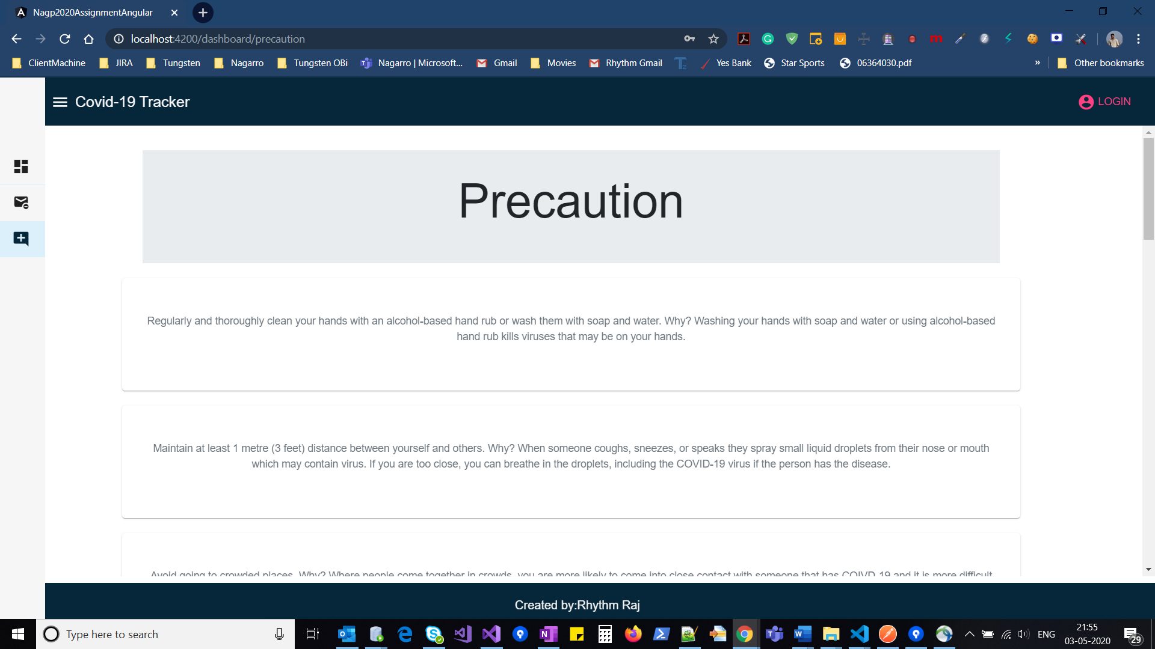

1. Login Screen: By clicking on the top right corner

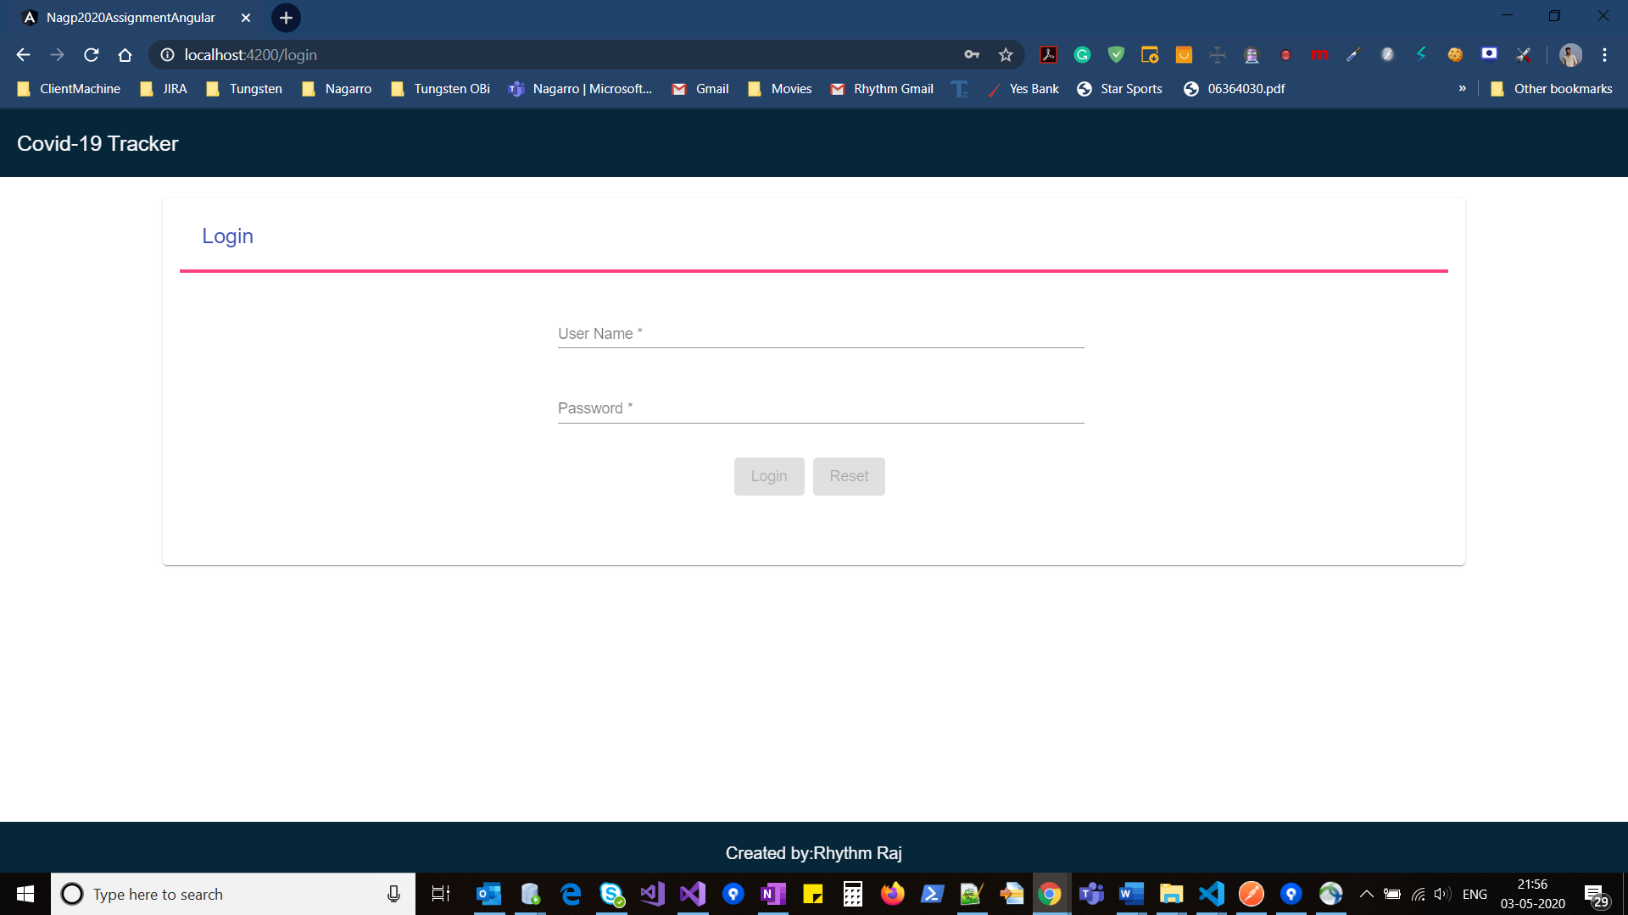

Proper Validation:

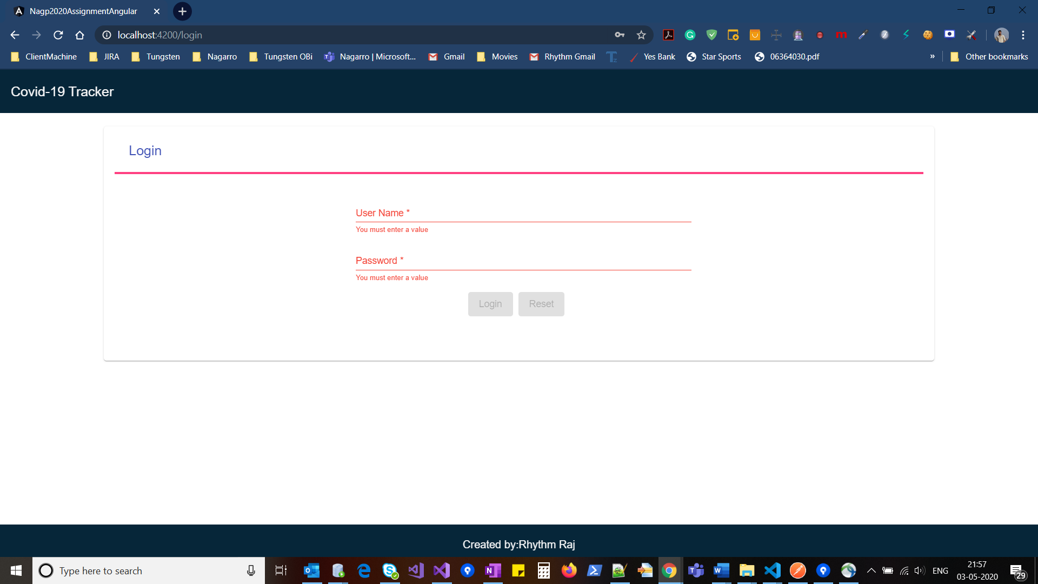

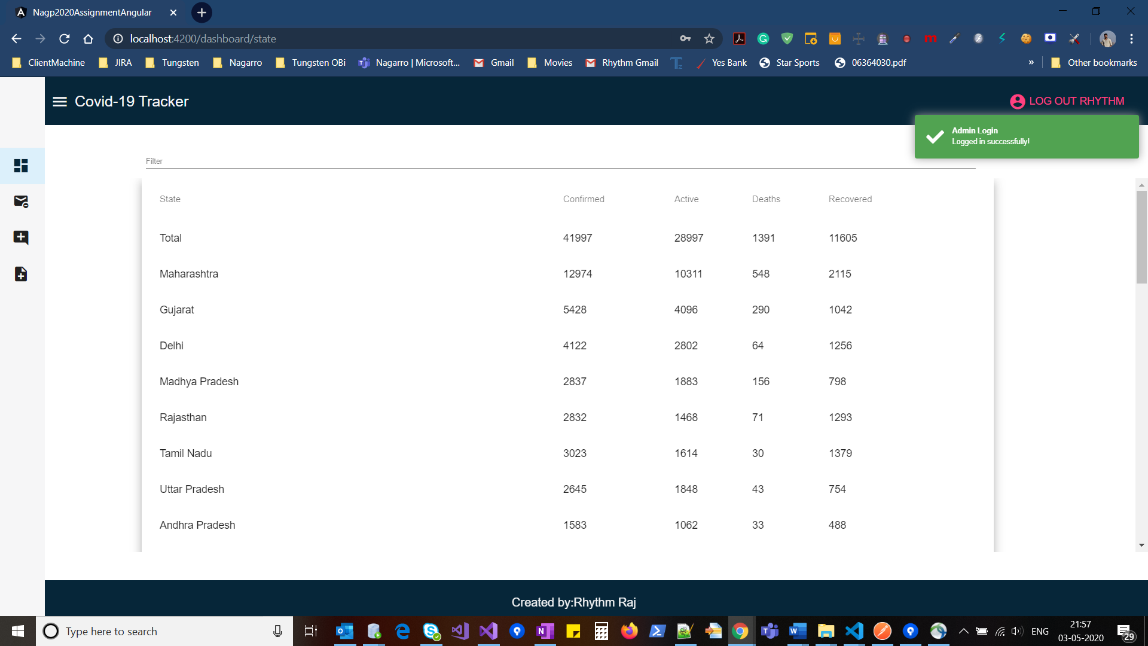

1. New option of add news is visible inside menu.

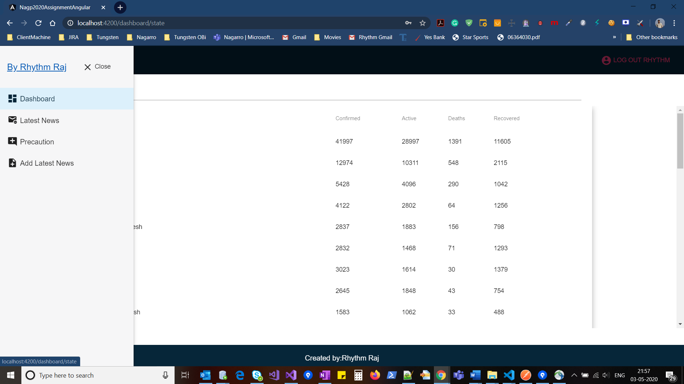

Note: Only Admin can add news.

1. Add news screen-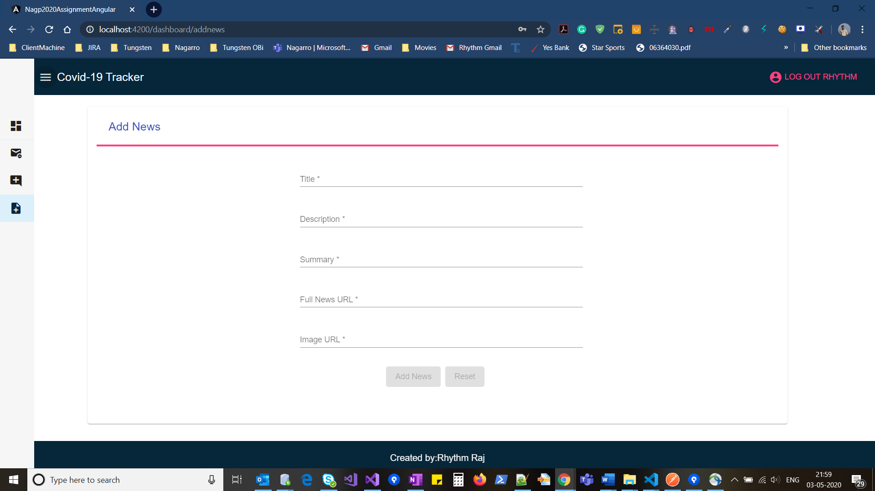

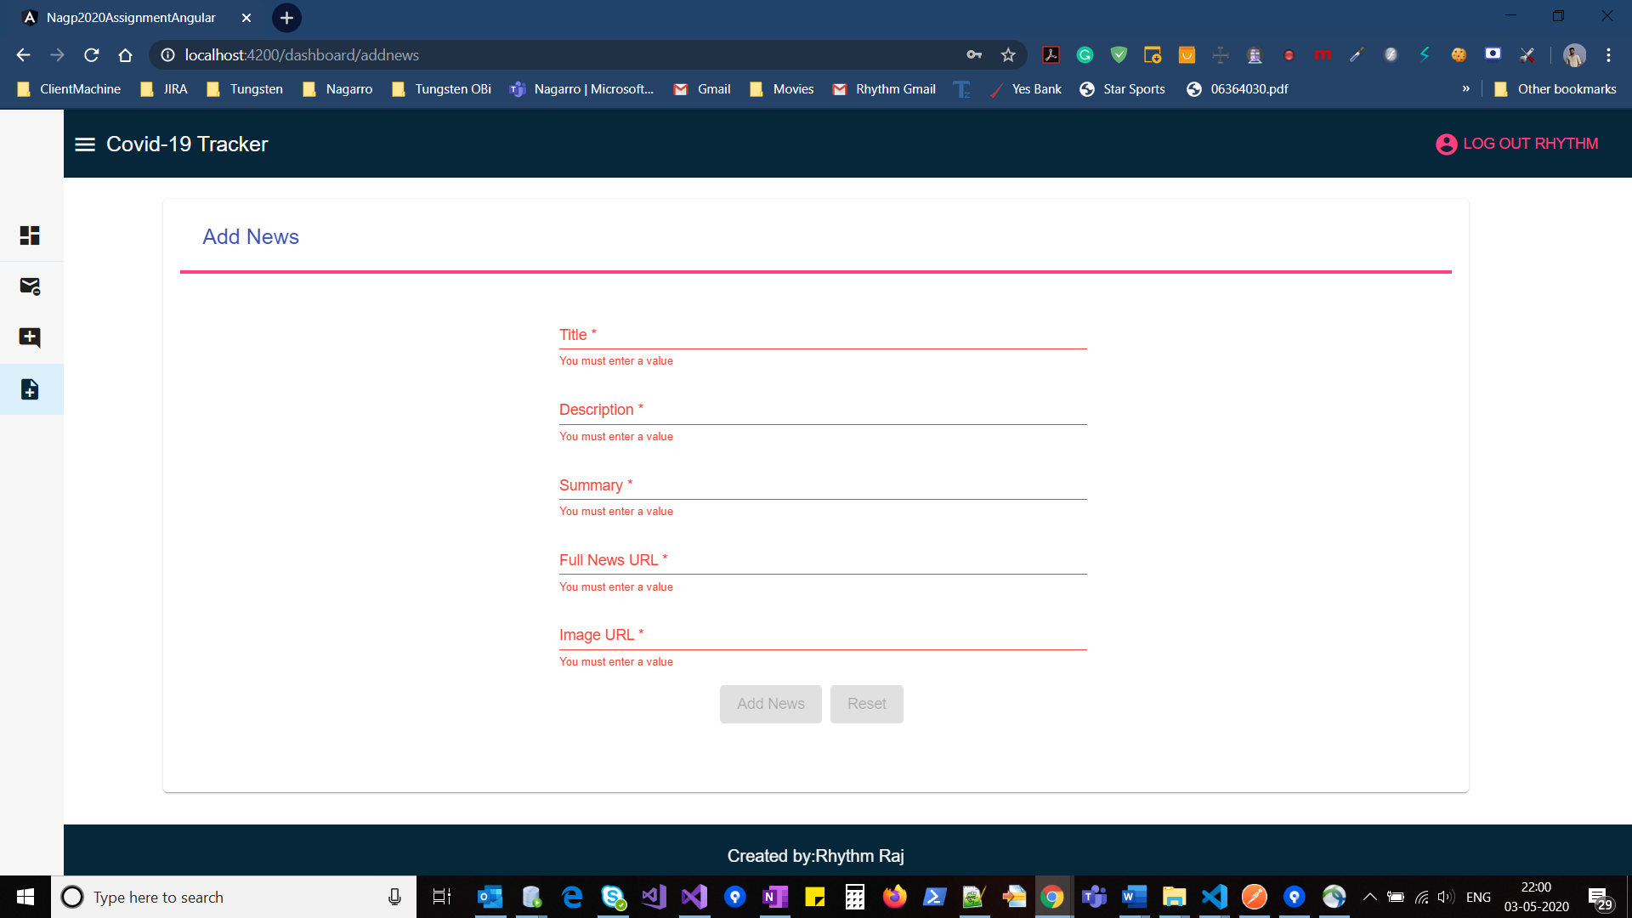

When admin adds a news, it will show in news section

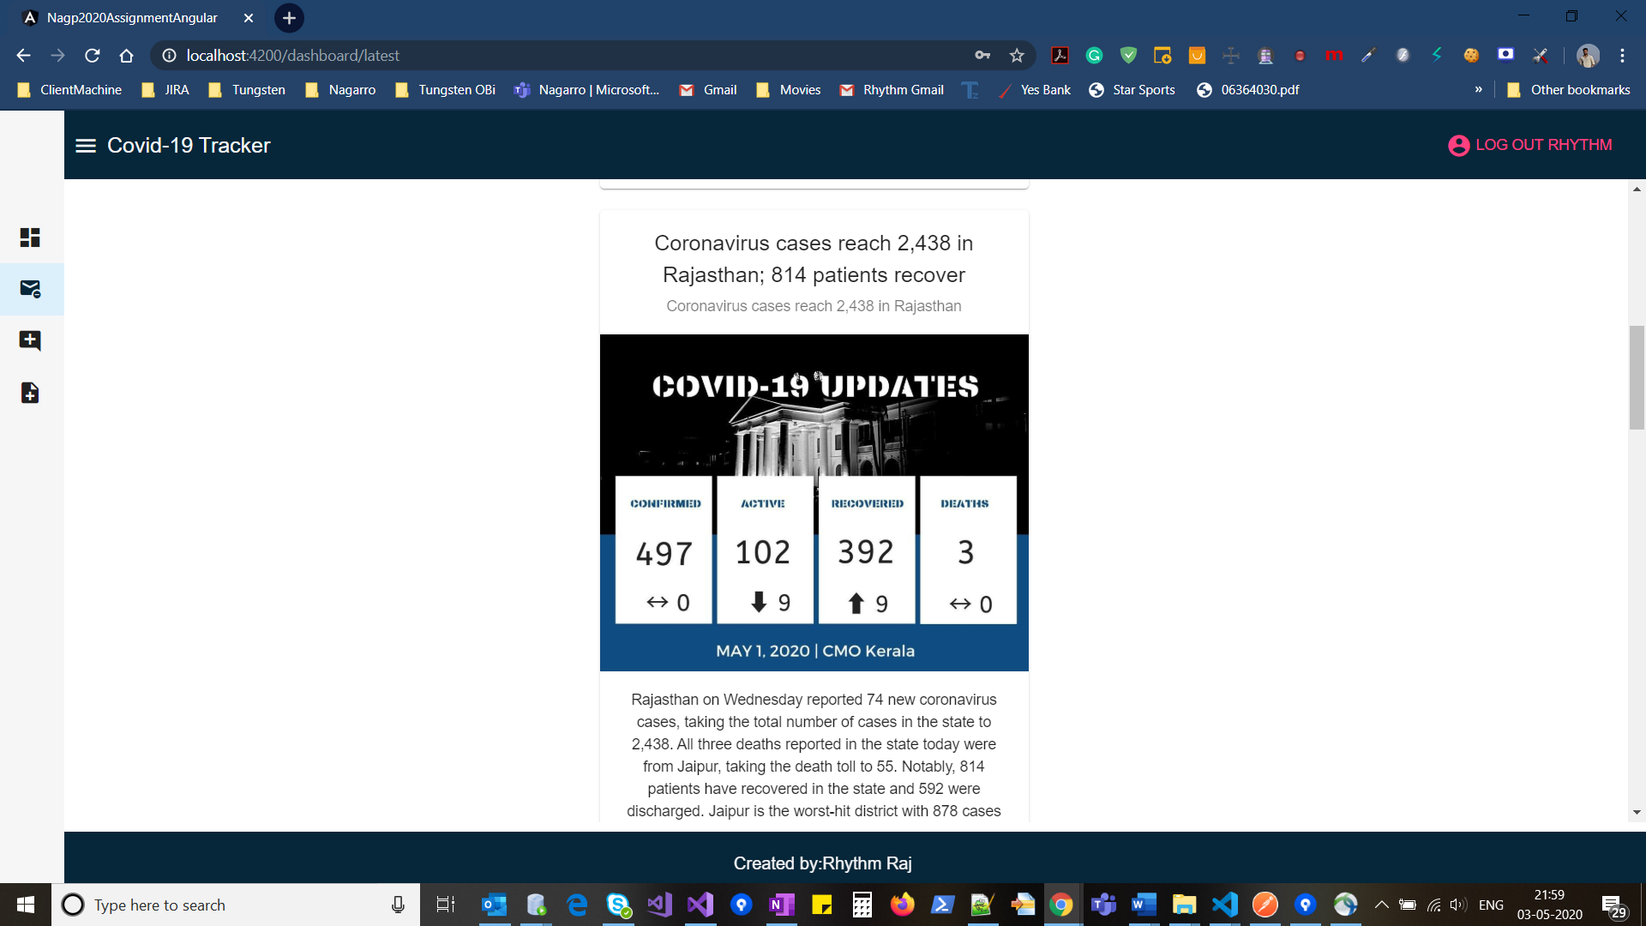

1. Used fake json server, fixed header and footer
2. Unit testing:

